**Nicolás Arroyo Márquez (1917, Havana – 2008, Washington D.C.) and Gabriela Menéndez García-Beltrán (1917, Havana – 2008, Washington D.C.), Architects**

The arrival of the modern movement in Cuba was marked not only by the rapid evolution of a new and diverse formal architectural language, but also for its surging interest in urban and regional planning as well as infrastructural development. Two key figures that represented this modernity in its broadest sense was the husband and wife team of Nicolás Arroyo Márquez and Gabriela Ménendez García-Beltrán. Together they formed the firm Arroyo y Menéndez, one of the more prolific architecture and planning offices in Havana during the 1950s. Throughout their brief yet prolific careers it can be said that their chief project was the integration of an international modernity into Cuban culture both at a civic and national level, as demonstrated by their commitment to public works, as well as on a private and domestic level as can be judged by their contributions to reshaping private dwelling space (being amongst the first to introduce the double-height unit to apartment design in Cuba) and furnishings (they were the representatives for Knoll furniture in Cuba).

Nicolás Arroyo received his training, like many of his generation, at the University of Havana, graduating with a degree in Architecture in 1941. Gabriela Menéndez matriculated from the same institution, completing her studies in the School of Engineering in 1937. She would later train as an architect, receiving a degree in this field from Columbia University in New York in 1941. The two married in December of 1942, around the same period that they formed their professional partnership.

Arroyo was a key founder of the *Agrupación Tectónica de Expresión Contemporánea* (ATEC), and together with the architect Eugenio Batista and urbanist Pedro Martínez Inclán was largely responsible for disseminating the theories of the *Congrés International d’Architecture Moderne* (CIAM) and introducing Cuban voices into the broader CIAM discourses. He attended CIAM 6 in Bridgwater, U.K. along with Batista.

The early architectural output of Arroyo and Menéndez reflected the broad range of stylistic tendencies in Cuba during the mid-century. This is perhaps most evident in their residential projects. Amongst their earliest works was their own personal residence, located in the affluent Miramar suburb of Havana. Completed in 1942, the modest residence is noted for its subtle references to the horizontality of Frank Lloyd Wright’s Prairie houses, as well as the corner treatments of its main vertical mass which alludes more strongly to Wright’s Fallingwater (1935).

Their use of formal language and methods of spatial organization evolved through the 1940’s, in particular with their Apartment Building for Berta García (1944). Situated within the dense 19th century grid of Central Havana, the building is notable for its maximization of dwelling space with use of duplex apartment units. The vertical organization of the units enabled the integration of a central patio between the two parallel dwelling blocks. With its façade marked by two prominent symmetrical towers encasing the stairwells and water tanks, as well as projecting balconies and an open concrete screen allowing visual permeability between the street and private patio, its formal composition displayed strong European rationalist influences.

This rational vocabulary would carry through with them into the next decade, as is evident in their Apartment Building for Carlos López (1950-1953). Bold symmetry remains a key feature in their aggregation of single level and duplex units. A more complex articulation of the façade is notable in this building, however, as is evident with the profusion of horizontal elements such as cantilevered balconies, terraces, beams, and ribbon windows, all working in counterpoint to the main horizontal masses of the complex. In the same year as the commencement of construction on this project, however, a shift toward a Corbusian modernism was evident with their Apartment Building for Enrique Menéndez (1950). In this building, the principle façade is clearly organized around a grid system defined by two levels of six duplex apartments. The result bears some resemblance to portions of the Unitè de Habitation in Marseille.

The changing political tide in Cuba benefited the careers of Arroyo and Menéndez. Close ties to the brother-in-law of Gen. Fulgencio Batista y Zaldívar, who claimed power in a 1952 coup d’etat, gave Arroyo an advantage in attaining larger government backed architectural projects. Notable amongst these is the commission for the Habana Hilton (1952-1958), a project in which the firm Arroyo and Menéndez worked alongside the principal design team of the American firm Welton Beckett and Associates. Standing at nearly 416 feet (127 meters) in height, the 27-story edifice was quickly recognized as a crowning achievement of Cuban modernity, an identity not lost following the triumph of the revolution when Fidel Castro installed his headquarters and the offices for the revolutionary government in the Hotel’s top floors.

Large public projects characterized the later part of the firm’s existence in Cuba. They received the commission for the National Theater (1954-1960), forming part of the monumental complex of the *Plaza Cívica* (the current *Plaza de la Revolución*). Eschewing the classical marble and nationalist jaiminitas stone monumentality of the plaza’s main edifices, the theater reflects a functionalist sensibility that more directly conveys the building’s use as a center of performance and ceremony. Its two trapezoidal auditoriums share the same central block for stage and machinery storage, reflecting an organizational layout that evokes Le Corbusier’s project for the Palace of Soviets (1928-1931). Intended to house the most advanced stage and sound equipment for its time, it remained incomplete at its inauguration in 1960, and would not be fully functional until its opening to the public in 1979.

A certain degree of urban monumentality could be found in their proposal for the *Ciudad Deportiva* or Sports City in the neighborhood of Cerro in Havana, however. Although the larger urban project remained unfinished at the time of the revolution, the large *Palacio de Deportes* or Sports Palace (1955-1957) was completed, representing significant achievements in local engineering with its thin shelled concrete dome reaching an unsupported span of 289 feet (88 meters) and a minimum thickness of just three inches (7 centimeters). Capable of seating between 12,000-15,000 spectators, its system circulation, organized into two major ramps, could effectively evacuate the space in ten minutes.

It is important to note the that the completion of these last three projects was likely realized in large part by Menéndez as her husband grew increasingly occupied with a career in politics and public service. Arroyo was granted a position in Fulgencio Batista’s government in 1955 as the Minister of Public Works. To further consolidate his charge over the island’s development, he was also named the director of the Junta Nacional de Planificación (JNP), a position that enabled him to invite Josep Lluís Sert and Paul Lester Wiener of Town Planning Associates (TPA) as consultants for the pilot plans for Havana, Varadero, Trinidad and the Isle of Pines. During this period he also initiated numerous infrastructural projects such as large scale highway construction, exemplified by the Via Monumental to Varadero and its massive bridge engineered by Luis Saenz at the Bacunayagua River. Also featured in the plan of development during his tenure was a network of new hospitals for the *Organización Nacional de Dispensarios Infantiles* (ONDI) or National Organization of Dispensaries for Children, all of which were completed following the revolution.

In 1958, Arroyo was appointed to the post of Cuban ambassador to the United States. He was the last person appointed by Fulgencio Batista to hold this position. With the change of political regimes in Cuba on New Year’s Eve 1958, Arroyo and Menéndez chose to remain in the United States. They continued to live in Washington D.C. where Arroyo continued working in architectural and construction projects. He became a member of the American Institute of Architects, and from 1971 to 1976 served on the U.S. Commission of Fine Arts. Ménendez passed away in Washington D.C. in July of 2008, followed three days afterwards by Arroyo.

Further Reading:

Rodríguez, Eduardo Luís (2000) *Havana Modern Guide: Modern Architecture 1925-*

*1965,* New York: Princeton Architectural Press.

Gómez Díaz, Francisco (2008) *De Forestier a Sert: ciudad y arquitectura en La*

*Habana de 1925 a 1960,* Madrid: Abada Editores, S.L.

Hyde, Timothy (2012) *Constitutional Modernism: Architecture and Civil Society 1933-*

*1959,* Minneapolis: University of Minnesota Press.

Jiménez, Guillermo (2007) *Los propietarios de Cuba 1958*, Havana: Editorial de

Ciencias Sociales, La Habana.

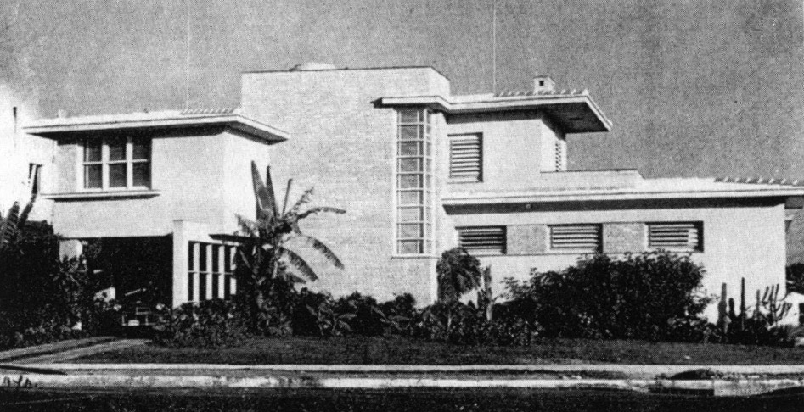

Personal House of Nicolás Arroyo and Gabriela Menéndez, 1942. (Image in *Havana Guide,* pg 58. Author credits image to “Toraya”)

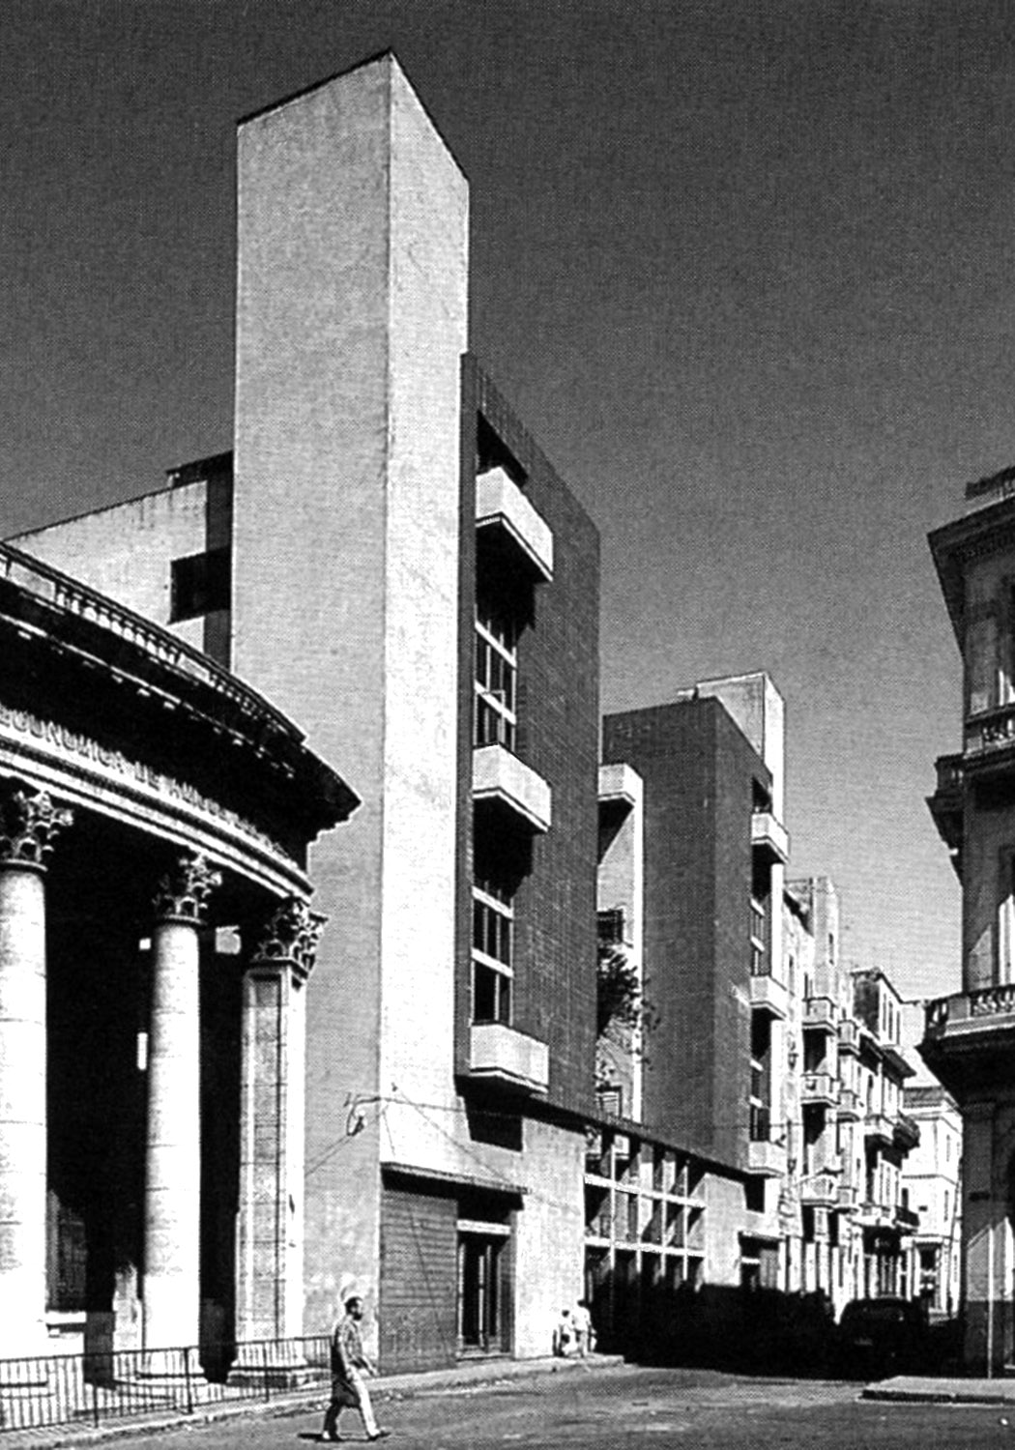

Apartment Building of Berta García, 1944. (Image in *Havana Guide,* pg 190. Photo by Eduardo Luís Rodríguez)

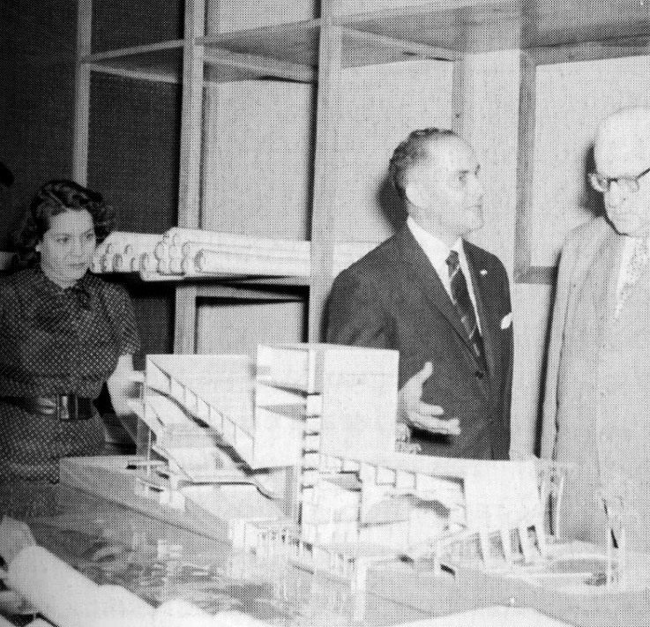 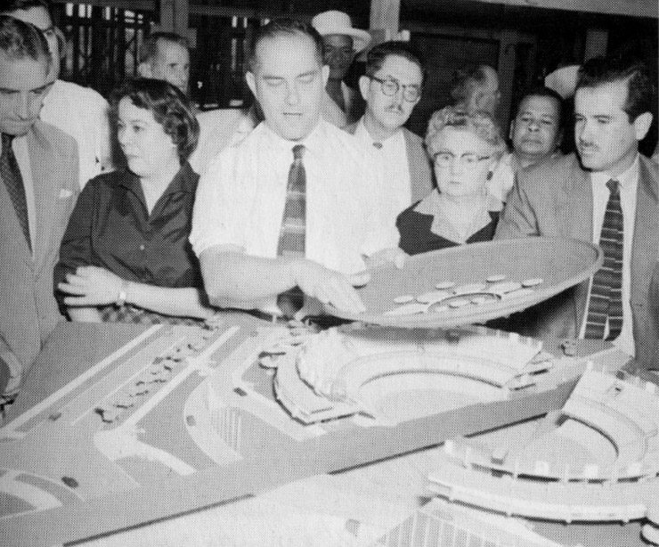

Left: Nicolás Arroyo and Gabriela Menéndez present the model for the National Theater, 1957. (Image in *De Forestier a Sert,* pg 431. Author credits image as belonging to the Archive of Juan de las Cuevas) Right: Arroyo and Menéndez explain the project for the Sports Palace to a general audience. (Image in *De Forestier a Sert,* pg 433. Author credits image as belonging to the Archive of Juan de las Cuevas)

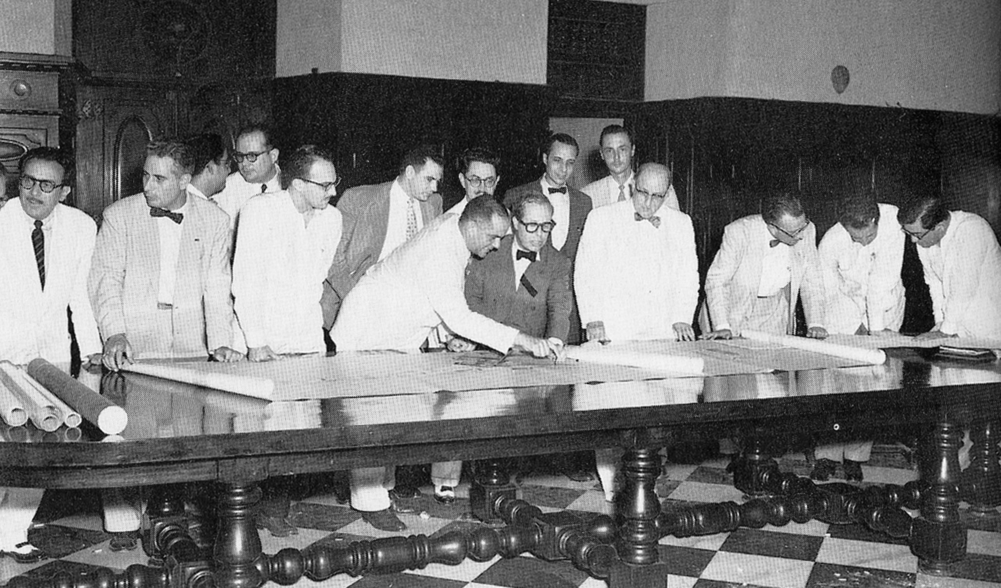

Meeting of the *Junta Nacional de Planificación* (JNP) with Nicolás Arroyo diplaying drawings to Josep Lluís Sert, ca. 1957. Also in the photo are: Eduardo Cañas Abril (far left); Mario Romañach (7th from left); and Eduardo Montoulieu (6th from right). (Image in *Havana Guide,* pg xx. Author credits image as “Archival.”)

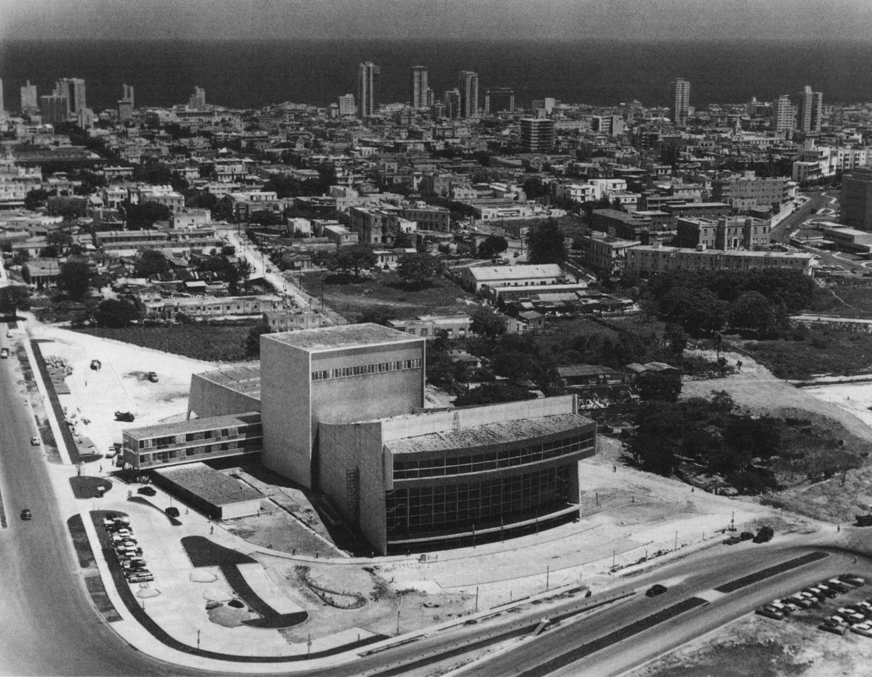

Aerial view of the National Theater, 1954-1960. . (Image in *La Habana: Arquitectura del Siglo XX,* pg 198. Author of image not stated).

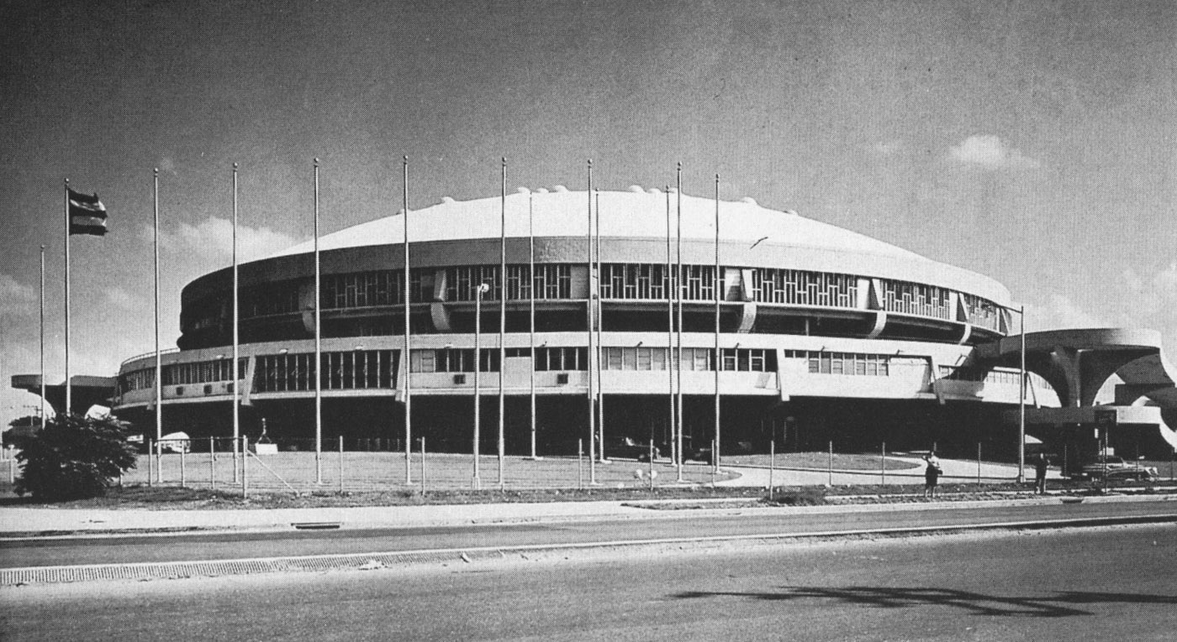

Apartment Building of Berta García, 1944. (Image in *Havana Guide,* pg 225. Author credits image as “Archival.”))